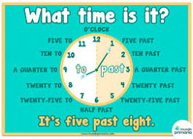
WRITE : WHAT TIME IS IT..??
10:00

11:15.

12:30.

9:20.

7:10.

8: 25.

6:10.

5.05.

