**ÁREAS DE POLIGONOS REGULARES**

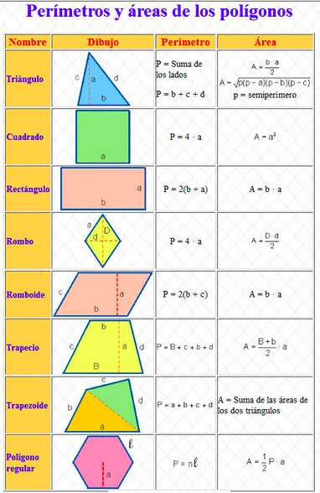

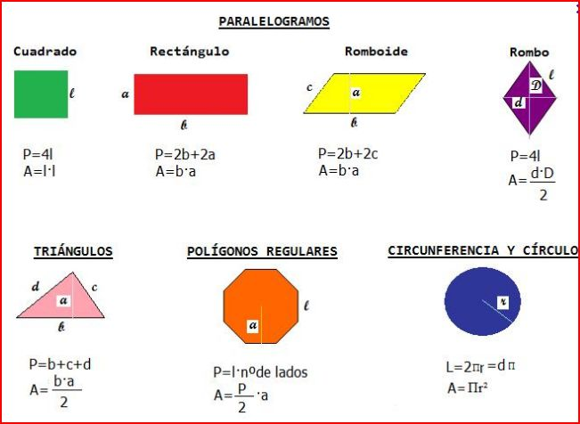

<https://www.youtube.com/watch?v=-RLXavtWcik>

<https://www.youtube.com/watch?v=emo_AubA2Fk>