[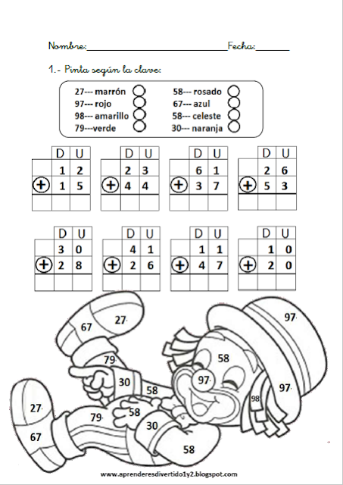](https://www.google.es/url?sa=i&url=https%3A%2F%2Fwww.pinterest.com%2Fpin%2F452963675016203862%2F&psig=AOvVaw1OK2z3URLuDTfldzbrpaAP&ust=1584823429020000&source=images&cd=vfe&ved=0CAIQjRxqFwoTCIjI7L71qegCFQAAAAAdAAAAABAE)