**ALTURAS**

**TRIÁNGULOS:**

[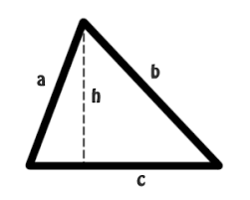](https://www.google.es/imgres?imgurl=https://1.bp.blogspot.com/-9n21JGxOLPM/Vs1rb4lu3II/AAAAAAAALgo/Ua_3NHu0GNc/s1600/triangulo1.png&imgrefurl=http://eliatron.blogspot.com/2016/02/calculando-la-altura-de-un-triangulo.html&tbnid=CZ1yIJtj3N49AM&vet=12ahUKEwi7jZq1ksfoAhWHwYUKHWp2CcIQMygdegQIARBI..i&docid=uDKvXPfzRP2lYM&w=300&h=240&q=imagenes%20de%20las%20alturas%20de%20los%20distintos%20tri%C3%A1ngulos&hl=es&gl=es&ved=2ahUKEwi7jZq1ksfoAhWHwYUKHWp2CcIQMygdegQIARBI) [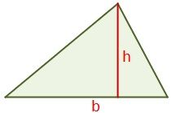](https://sites.google.com/site/geometriagradonoveno/perimetro-y-area-de-un-triangulo)

[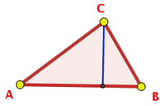](https://www.google.es/url?sa=i&url=http://geogebra.es/cvg_primaria/04/html/altura.html&psig=AOvVaw2S3akxdfer7H41_l4wQzdQ&ust=1585827628835000&source=images&cd=vfe&ved=0CAIQjRxqFwoTCMiro7aSx-gCFQAAAAAdAAAAABAE) [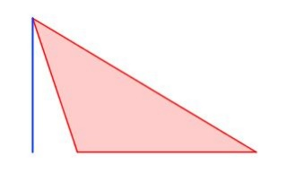](https://www.google.es/url?sa=i&url=http://agrega.juntadeandalucia.es/repositorio/04022011/a1/es-an_2011020413_9131355/ODE-4f24774b-c33c-363e-a06a-d19cc203da26/22_rea_de_un_tringulo.html&psig=AOvVaw2S3akxdfer7H41_l4wQzdQ&ust=1585827628835000&source=images&cd=vfe&ved=0CAIQjRxqFwoTCMiro7aSx-gCFQAAAAAdAAAAABAk)

[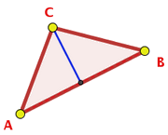](https://www.google.es/url?sa=i&url=http://geogebra.es/gauss/materiales_didacticos/primaria/actividades/geometria/poligonos/altura_triangulo/teoria.htm&psig=AOvVaw2S3akxdfer7H41_l4wQzdQ&ust=1585827628835000&source=images&cd=vfe&ved=0CAIQjRxqFwoTCMiro7aSx-gCFQAAAAAdAAAAABAK) [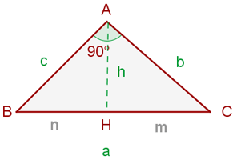](https://www.google.es/url?sa=i&url=https://didactalia.net/comunidad/materialeducativo/recurso/teorema-de-la-altura-explicacion-y-ejemplo-vitutor/d458fb70-0f27-4d5d-b450-74fdda1781cd&psig=AOvVaw2S3akxdfer7H41_l4wQzdQ&ust=1585827628835000&source=images&cd=vfe&ved=0CAIQjRxqFwoTCMiro7aSx-gCFQAAAAAdAAAAABAY)[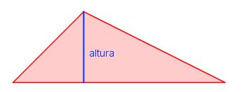](https://www.google.es/url?sa=i&url=http://agrega.juntadeandalucia.es/repositorio/04022011/a1/es-an_2011020413_9131355/ODE-4f24774b-c33c-363e-a06a-d19cc203da26/22_rea_de_un_tringulo.html&psig=AOvVaw2S3akxdfer7H41_l4wQzdQ&ust=1585827628835000&source=images&cd=vfe&ved=0CAIQjRxqFwoTCMiro7aSx-gCFQAAAAAdAAAAABAf) [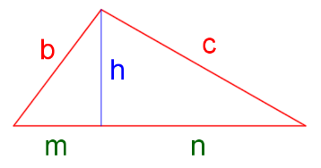](https://www.google.es/url?sa=i&url=https://mediateca.educa.madrid.org/imagen/zrzft7ha2rbd61s8&psig=AOvVaw2S3akxdfer7H41_l4wQzdQ&ust=1585827628835000&source=images&cd=vfe&ved=0CAIQjRxqFwoTCMiro7aSx-gCFQAAAAAdAAAAABAU)

**ALTURA CORRESPONDIENTE A LA BASE AB DE:**

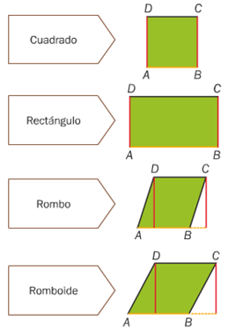

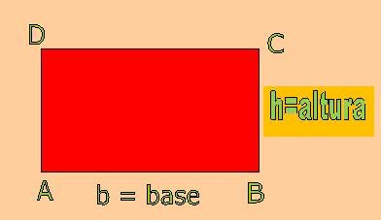

[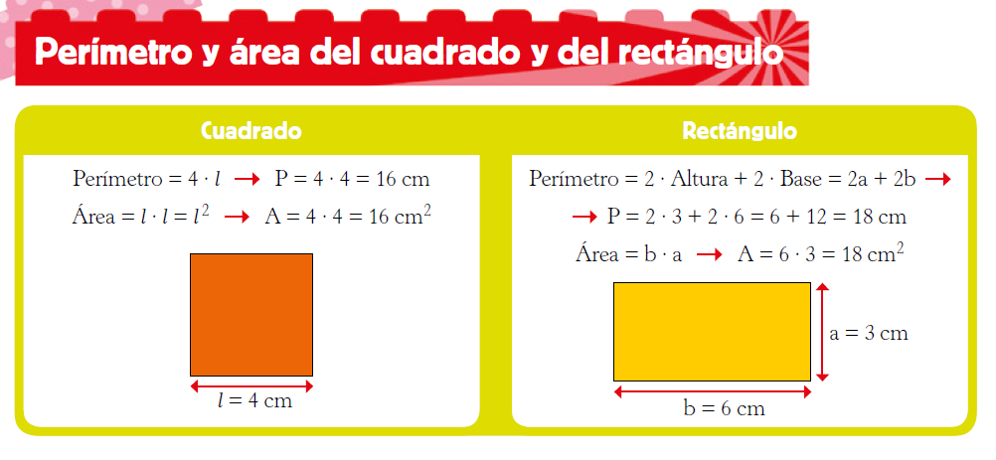](https://www.google.es/url?sa=i&url=https%3A%2F%2Fblogsaverroes.juntadeandalucia.es%2Faula6b%2F2020%2F04%2F14%2Fperimetro-y-area-del-cuadrado-y-del-rectangulo%2F&psig=AOvVaw1PNexZaCIiKkIv0sUnjH2s&ust=1587221920843000&source=images&cd=vfe&ved=0CAIQjRxqFwoTCLj1xNPc7-gCFQAAAAAdAAAAABAc)

[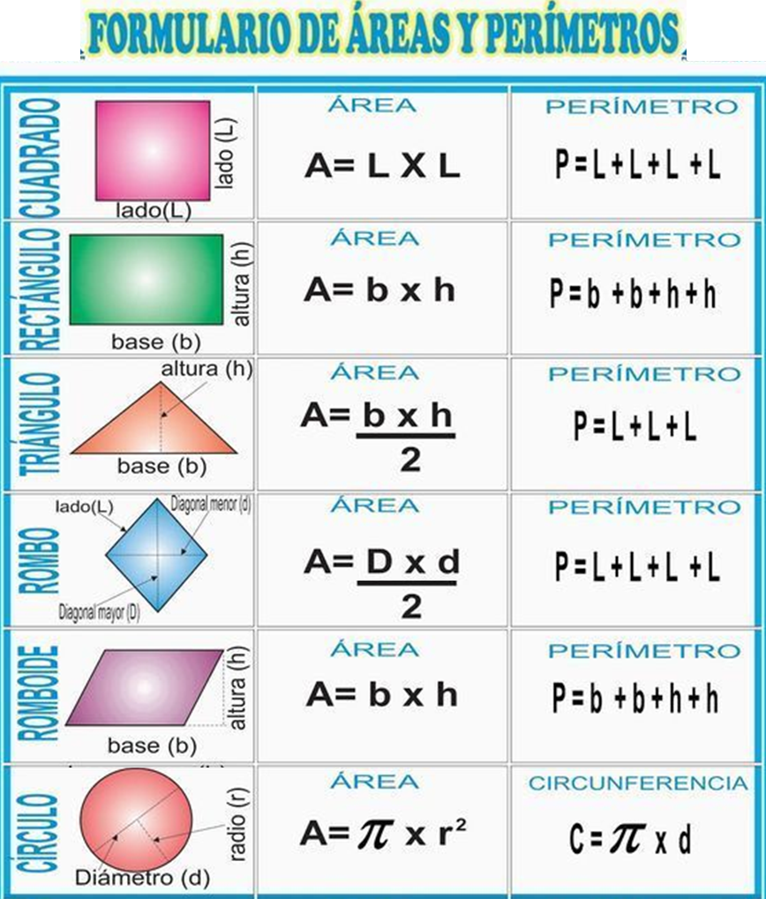](https://www.google.es/url?sa=i&url=https%3A%2F%2Fterefernandezvazquez.blogspot.com%2F2018%2F06%2Fsuperficie-y-area.html&psig=AOvVaw3mSaq4Pt399fheuVsDqaHO&ust=1587222126989000&source=images&cd=vfe&ved=0CAIQjRxqFwoTCMDptbHd7-gCFQAAAAAdAAAAABAO)