**ÁREAS**

[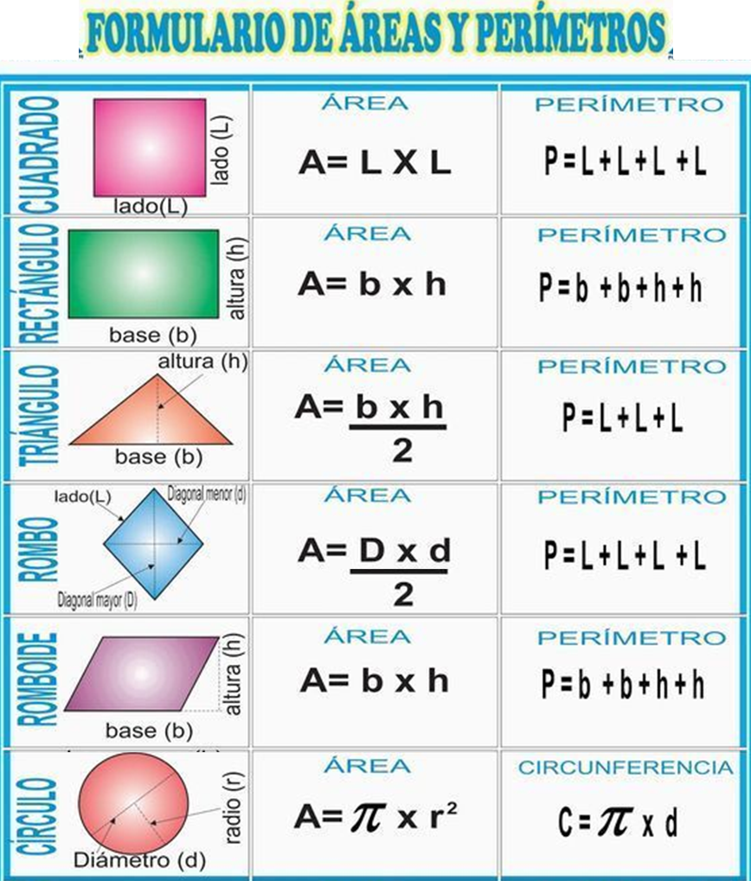](https://www.google.es/url?sa=i&url=https://terefernandezvazquez.blogspot.com/2018/06/superficie-y-area.html&psig=AOvVaw3mSaq4Pt399fheuVsDqaHO&ust=1587222126989000&source=images&cd=vfe&ved=0CAIQjRxqFwoTCMDptbHd7-gCFQAAAAAdAAAAABAO)

[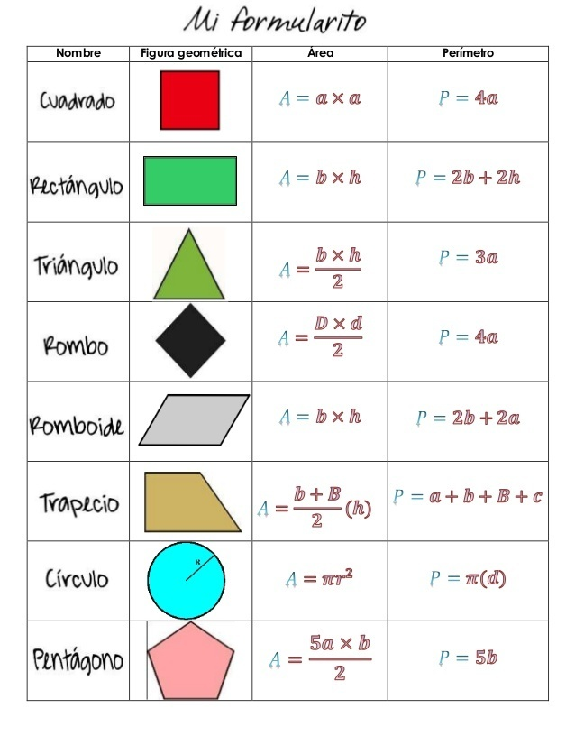](https://www.google.es/url?sa=i&url=https://brainly.lat/tarea/10192680&psig=AOvVaw3xeP3WGxwPtJk6-NyrY3nA&ust=1585835303754000&source=images&cd=vfe&ved=0CAIQjRxqFwoTCKCnoYKvx-gCFQAAAAAdAAAAABAv)

[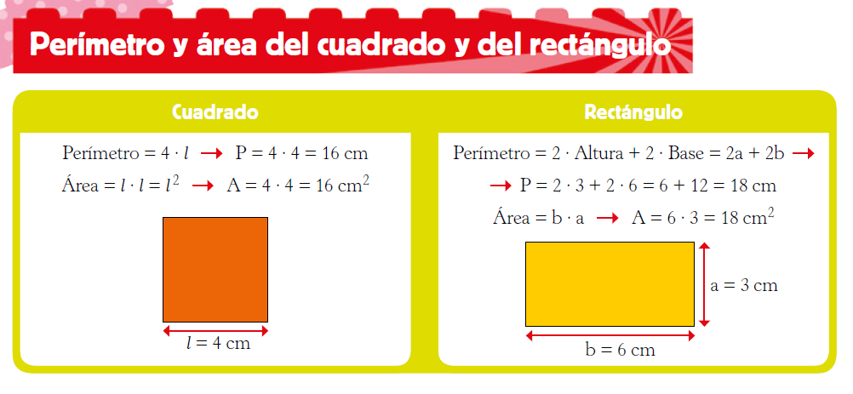](https://www.google.es/url?sa=i&url=https://blogsaverroes.juntadeandalucia.es/aula6b/2020/04/14/perimetro-y-area-del-cuadrado-y-del-rectangulo/&psig=AOvVaw1PNexZaCIiKkIv0sUnjH2s&ust=1587221920843000&source=images&cd=vfe&ved=0CAIQjRxqFwoTCLj1xNPc7-gCFQAAAAAdAAAAABAc)

[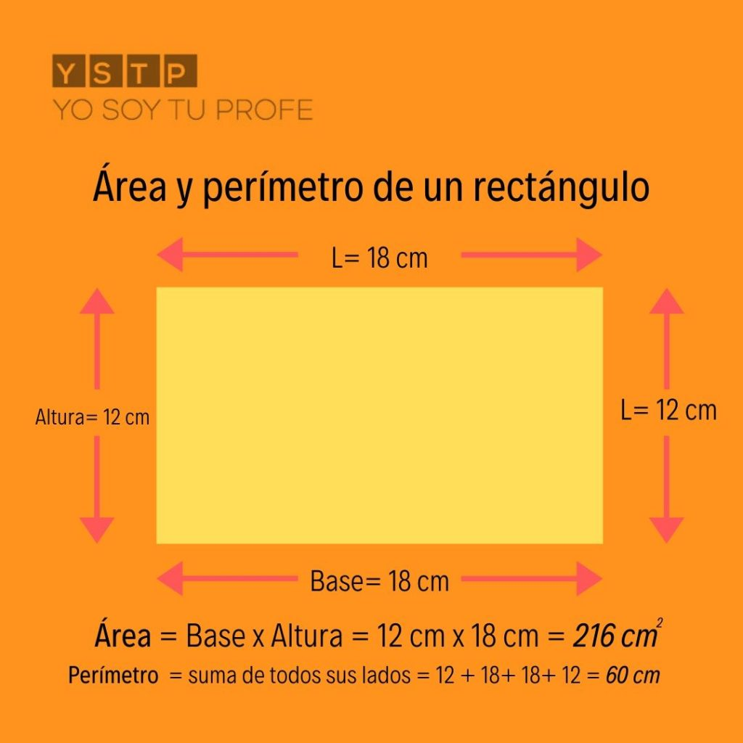](https://www.google.es/url?sa=i&url=https://yosoytuprofe.20minutos.es/2019/10/01/area-y-perimetro-de-un-rectangulo/&psig=AOvVaw080PBkH6Sq5Py6-Ytol9Ln&ust=1587221499682000&source=images&cd=vfe&ved=0CAIQjRxqFwoTCJDQl47b7-gCFQAAAAAdAAAAABAP)

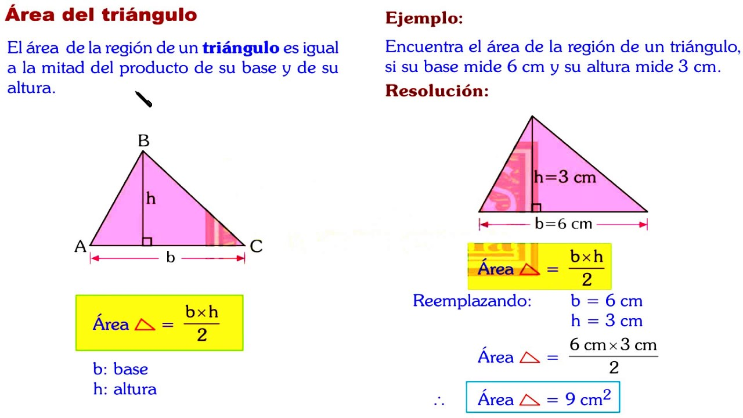

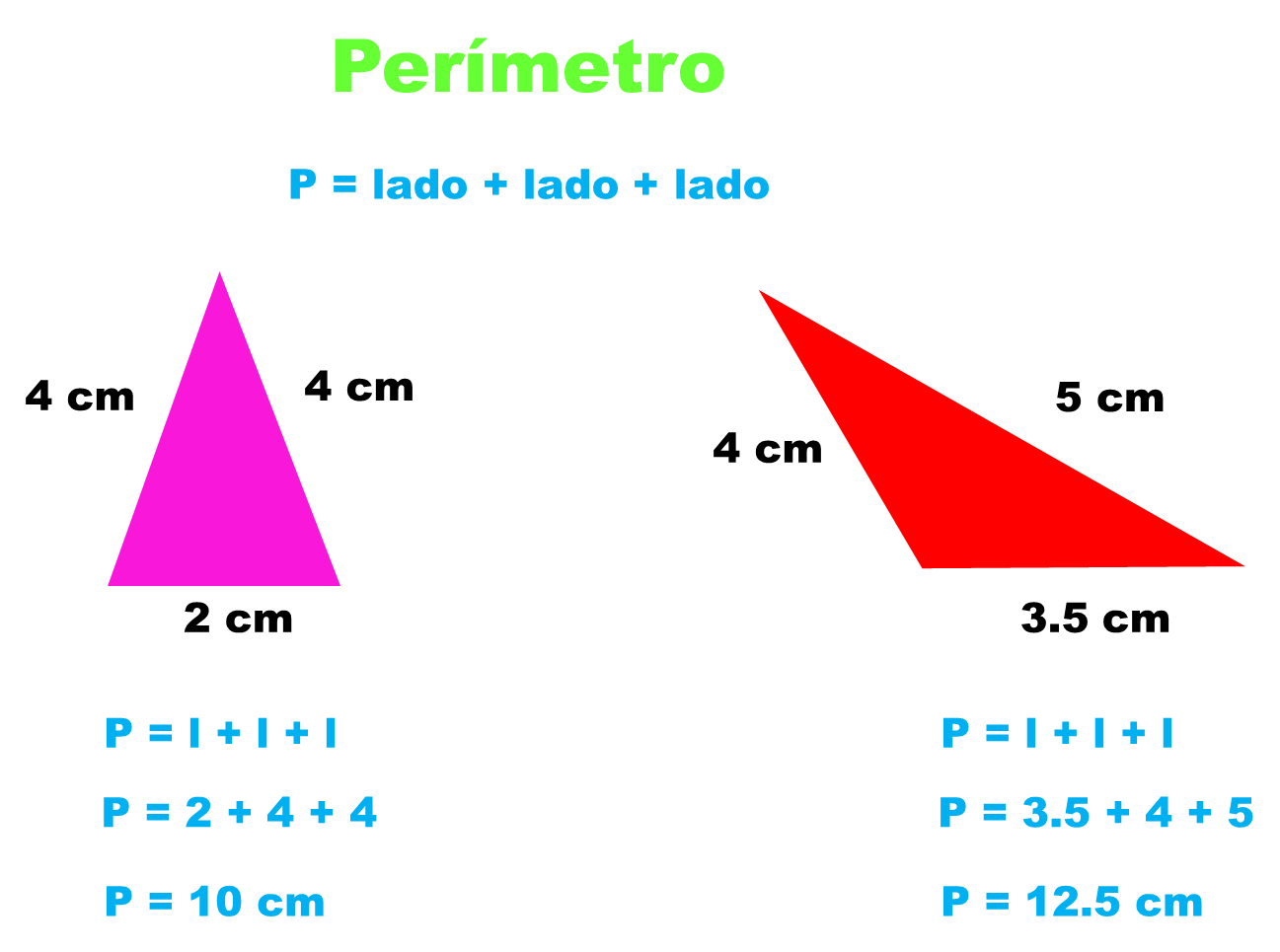

[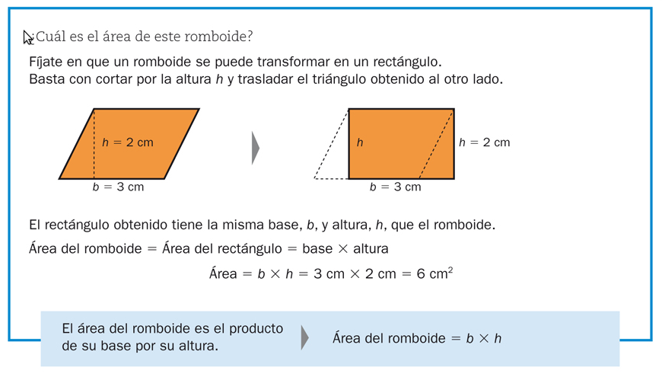](https://www.google.es/url?sa=i&url=http%3A%2F%2Fnuestrazonasextomatematicas.blogspot.com%2F2011%2F03%2Farea-del-rombo-romboide-y-triangulo.html&psig=AOvVaw0O94nB_-awPwM3038ryrTm&ust=1587627617085000&source=images&cd=vfe&ved=0CAIQjRxqFwoTCJiQvPTD--gCFQAAAAAdAAAAABAV)

[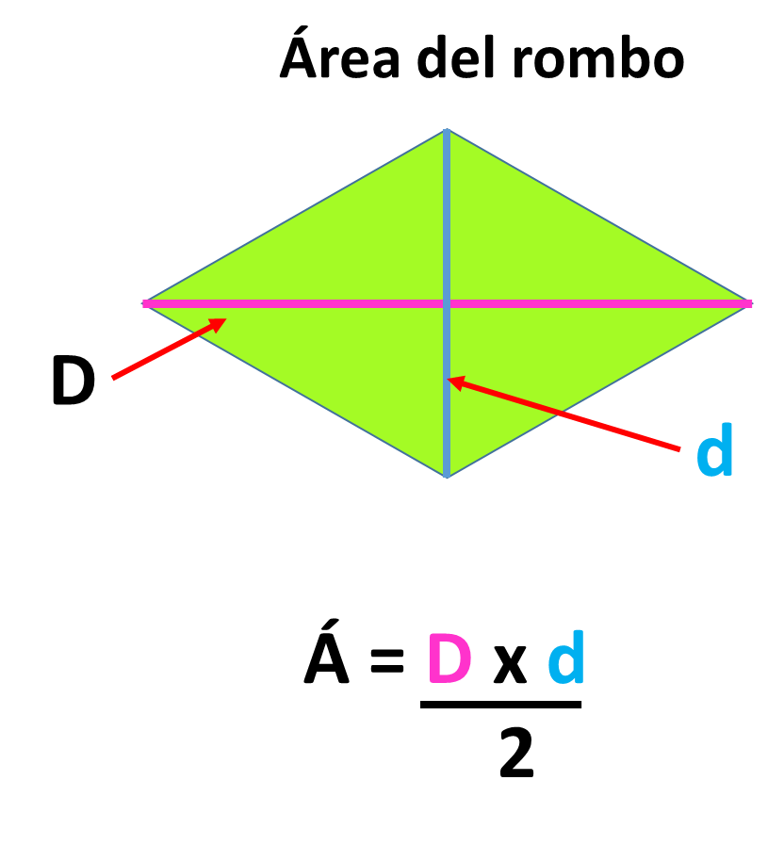](https://www.google.es/url?sa=i&url=https%3A%2F%2Fmatematicasparaticharito.wordpress.com%2Ftag%2Fdiagonales-del-rombo%2F&psig=AOvVaw0O94nB_-awPwM3038ryrTm&ust=1587627617085000&source=images&cd=vfe&ved=0CAIQjRxqFwoTCJiQvPTD--gCFQAAAAAdAAAAABAh)

[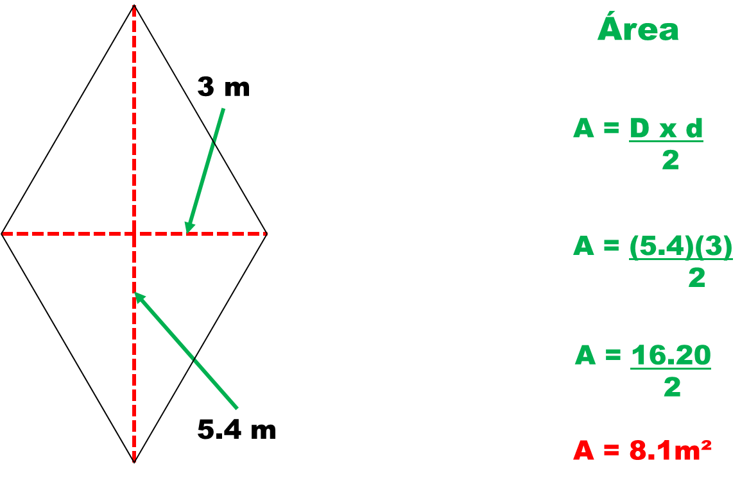](https://www.google.es/url?sa=i&url=https%3A%2F%2Fmatematicasparaticharito.wordpress.com%2Ftag%2Fformula-para-obtener-el-area-del-trapecio%2F&psig=AOvVaw0O94nB_-awPwM3038ryrTm&ust=1587627617085000&source=images&cd=vfe&ved=0CAIQjRxqFwoTCJiQvPTD--gCFQAAAAAdAAAAABAm)