LA PANADERÍA

[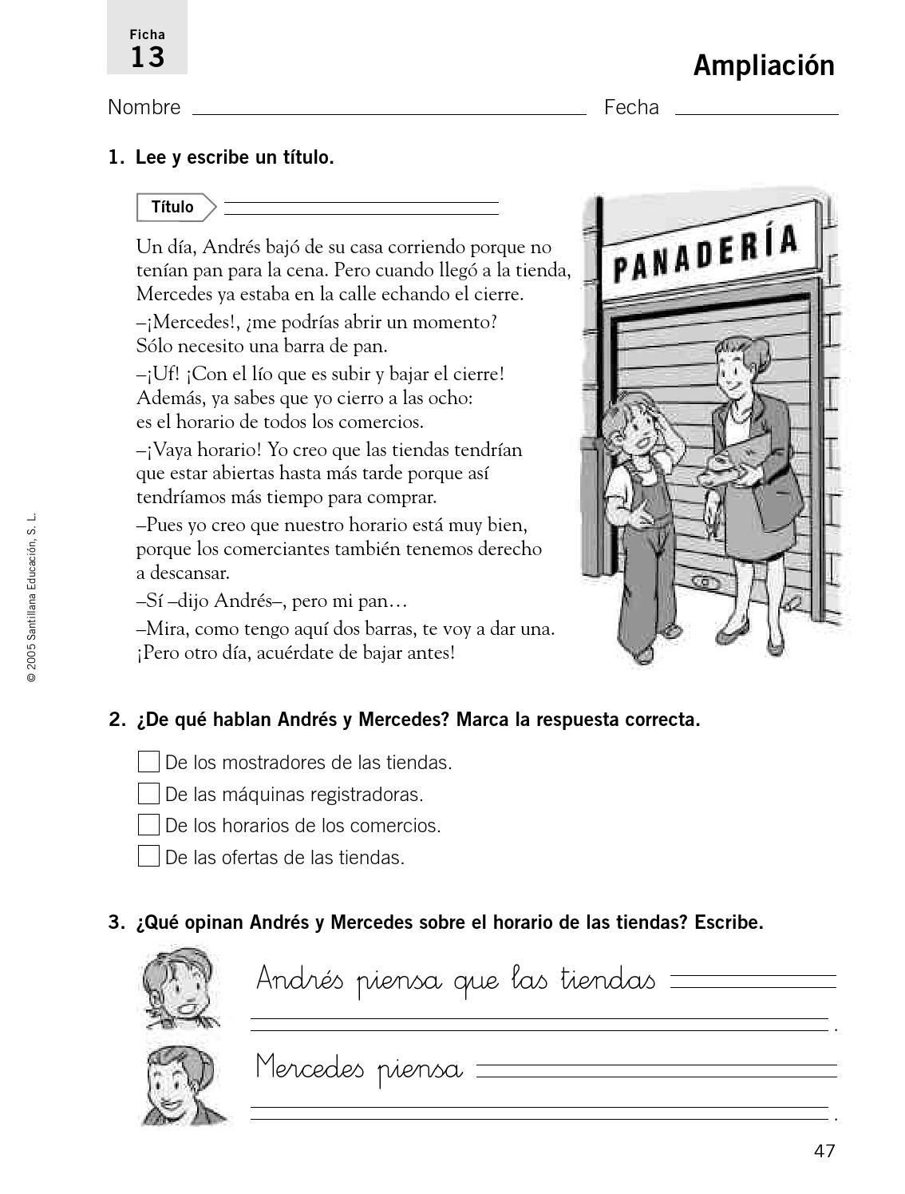](https://www.google.es/url?sa=i&url=https%3A%2F%2Fwww.pinterest.com%2Fpin%2F570338740305000413%2F&psig=AOvVaw2AO70rLPsc7otyw0xhRJ2z&ust=1588146302397000&source=images&cd=vfe&ved=0CAIQjRxqGAoTCPDJuZrQiukCFQAAAAAdAAAAABCWAQ)