[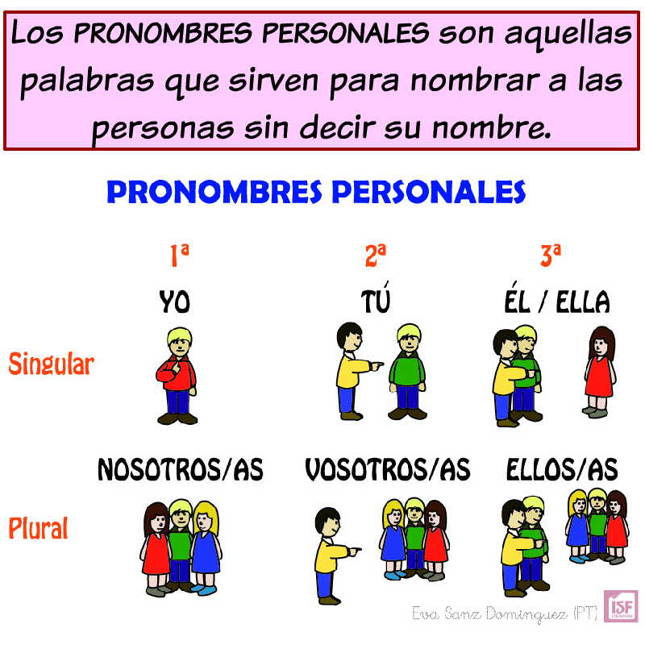](https://www.google.es/url?sa=i&url=https%3A%2F%2Fwww.pinterest.com%2Fpin%2F729301733377781546%2F&psig=AOvVaw2lHFmASdX5ScvLU4S9hfjT&ust=1587800345950000&source=images&cd=vfe&ved=0CAIQjRxqFwoTCMj748rHgOkCFQAAAAAdAAAAABAD)