**SIGNOS DE PUNTUACIÓN**

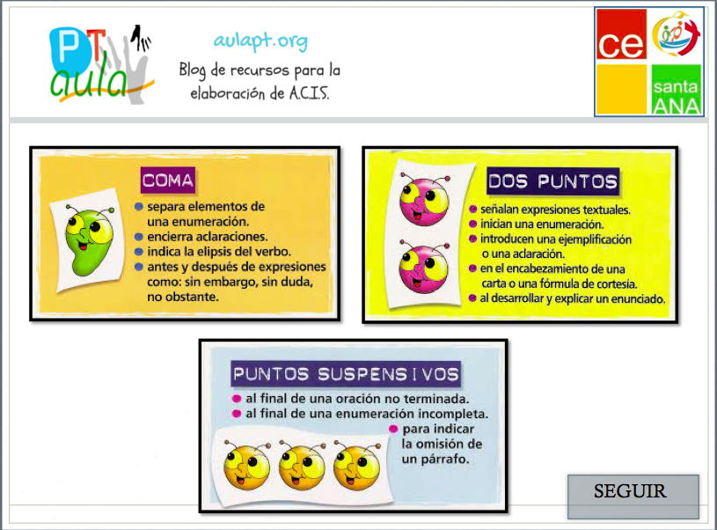 ,

 :

 …

[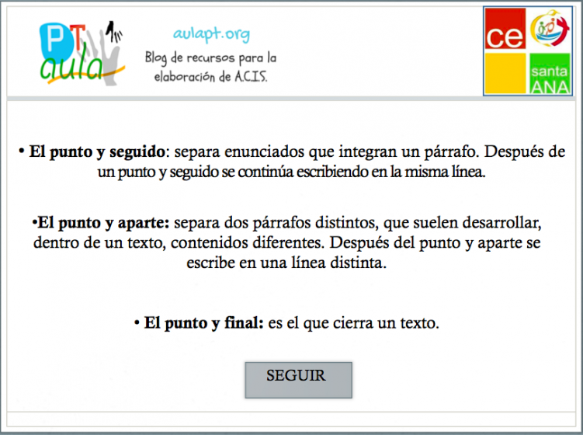](https://www.aulapt.org/wp-content/uploads/2018/05/ortografía2.png)

[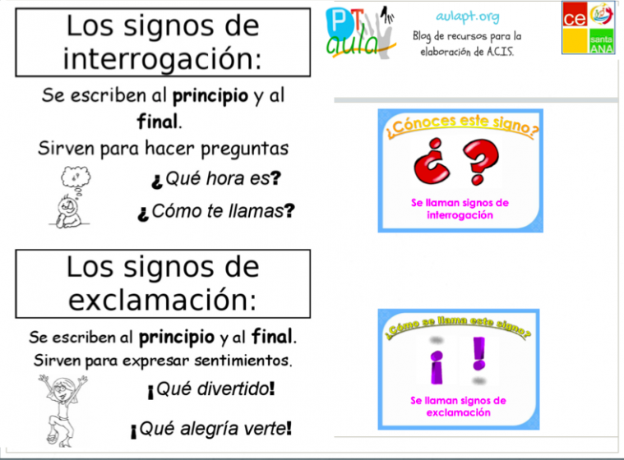](https://www.aulapt.org/wp-content/uploads/2018/05/ortografía3.png) [](https://www.aulapt.org/wp-content/uploads/2018/05/ortografía3.png)