**TIEMPOS VERBALES**

[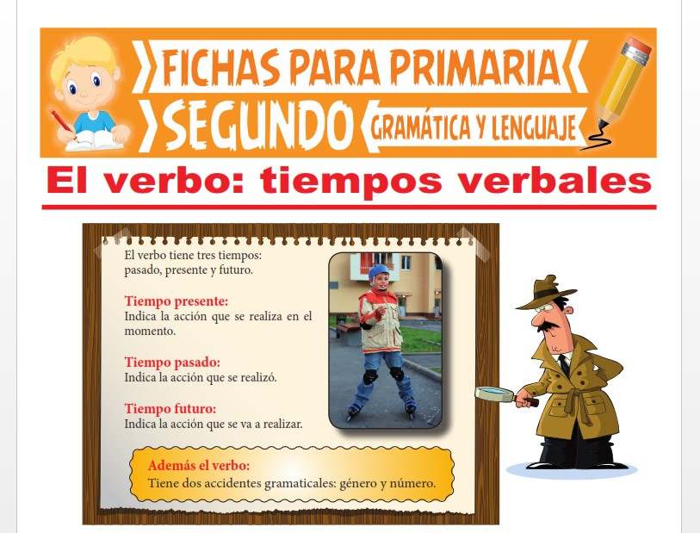](https://www.google.es/url?sa=i&url=https%3A%2F%2Ffraekmuendt.com%2Fimages%2Fejercicios-verbos-presente-pasado-y-futuro-2o-primaria.htm&psig=AOvVaw1GEzzvI2YV8rYI8YW0KTQK&ust=1588332271686000&source=images&cd=vfe&ved=0CAIQjRxqFwoTCNDWrIKFkOkCFQAAAAAdAAAAABAD)

[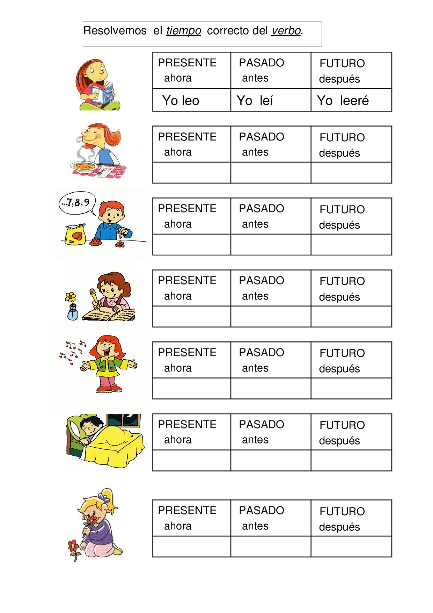](https://www.google.es/url?sa=i&url=https%3A%2F%2Fwww.docsity.com%2Fes%2Festudio-del-verbo-primaria%2F3217508%2F&psig=AOvVaw21LPXChYANSQOuPa-x6EGq&ust=1588332606741000&source=images&cd=vfe&ved=0CAIQjRxqFwoTCListp2GkOkCFQAAAAAdAAAAABAR)

[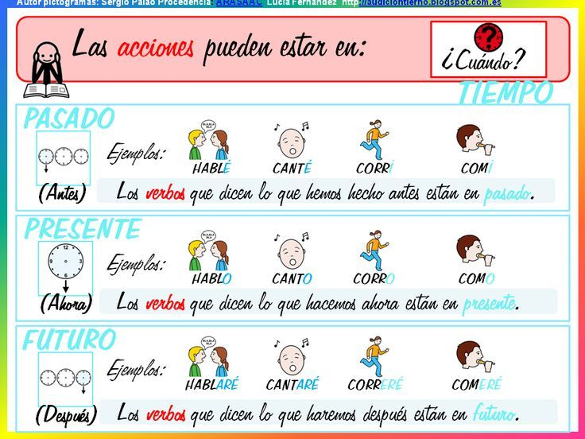](https://www.google.es/url?sa=i&url=https%3A%2F%2Fwww.pinterest.at%2Fpin%2F523191681702647071%2F&psig=AOvVaw21LPXChYANSQOuPa-x6EGq&ust=1588332606741000&source=images&cd=vfe&ved=0CAIQjRxqFwoTCListp2GkOkCFQAAAAAdAAAAABAb)