**ÁREA Y PERÍMETRODE FGURAS PLANAS**

[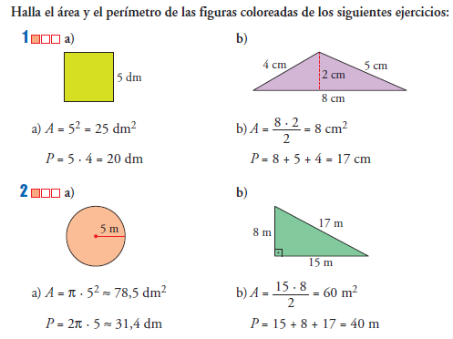](https://www.google.es/url?sa=i&url=https%3A%2F%2Fejercicios.me%2Fareas-perimetros-figuras-planas%2F&psig=AOvVaw2lJlw7XpMWItBlFTtKdSy0&ust=1588347713402000&source=images&cd=vfe&ved=0CAIQjRxqFwoTCNC_yby-kOkCFQAAAAAdAAAAABAD)

[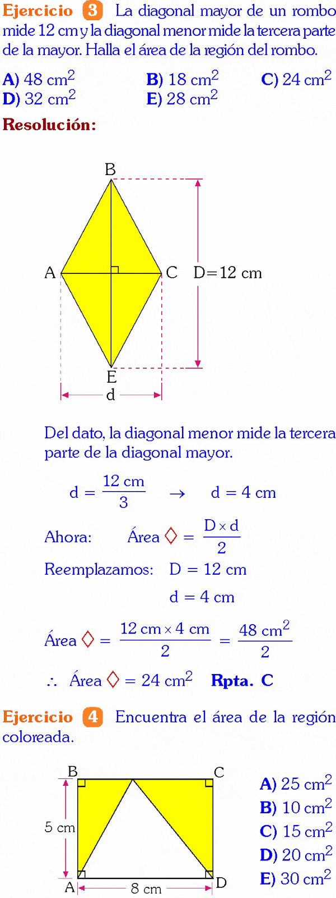](https://www.google.es/url?sa=i&url=https%3A%2F%2Fmatematicasn.blogspot.com%2F2015%2F12%2Fareas-y-perimetros-ejercicios-resueltos.html&psig=AOvVaw2lJlw7XpMWItBlFTtKdSy0&ust=1588347713402000&source=images&cd=vfe&ved=0CAIQjRxqFwoTCNC_yby-kOkCFQAAAAAdAAAAABA8)