**EXPLICACIÓN 6º B MARTES 19 MAYO.**

**LA VOZ DEL VERBO:**

[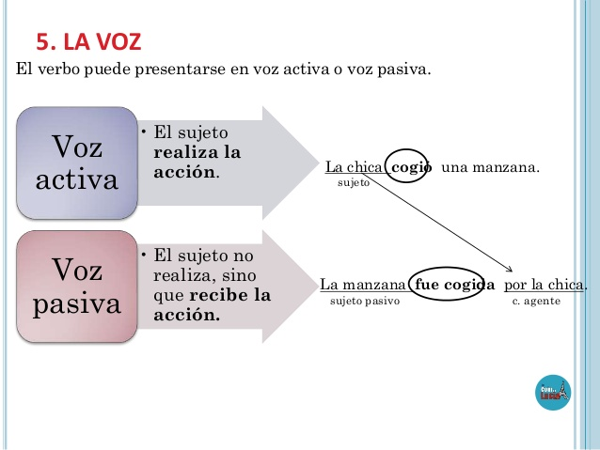](https://www.google.es/url?sa=i&url=https%3A%2F%2Fes.slideshare.net%2Fnaiades83%2Fel-verbo-30813626&psig=AOvVaw1rWOcF9spZAApc3-lF2kNR&ust=1589891624555000&source=images&cd=vfe&ved=0CAIQjRxqFwoTCPiEn_-1vekCFQAAAAAdAAAAABAQ)

[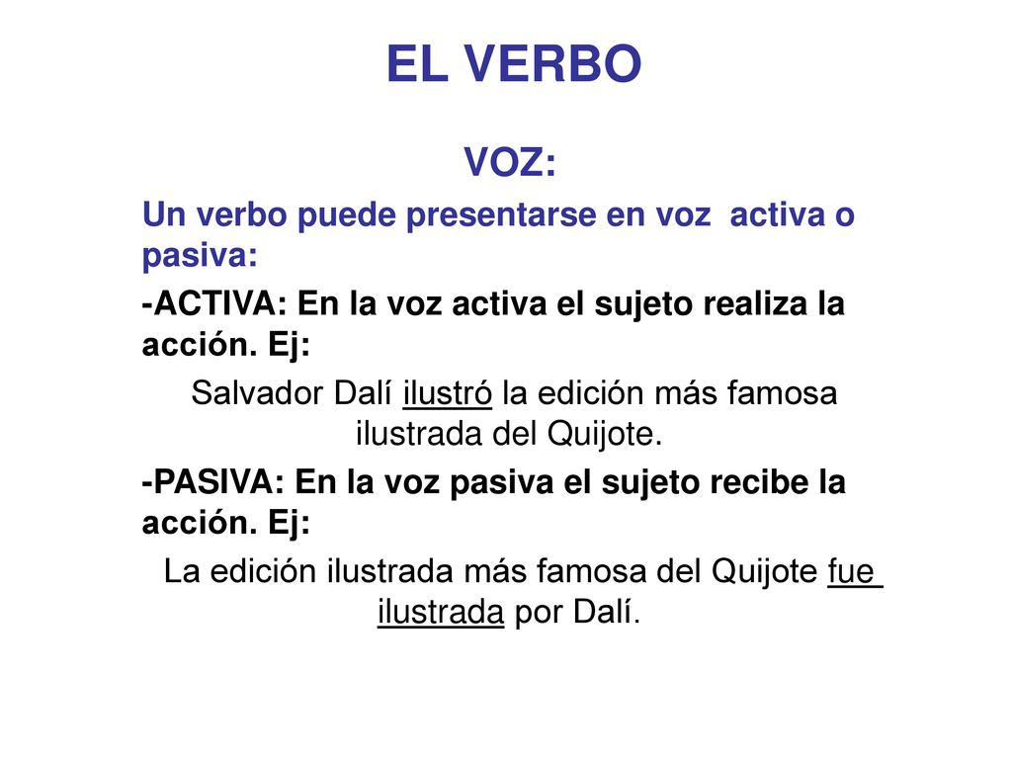](https://www.google.es/url?sa=i&url=https%3A%2F%2Fslideplayer.es%2Fslide%2F12345384%2F&psig=AOvVaw1rWOcF9spZAApc3-lF2kNR&ust=1589891624555000&source=images&cd=vfe&ved=0CAIQjRxqFwoTCPiEn_-1vekCFQAAAAAdAAAAABAD)

[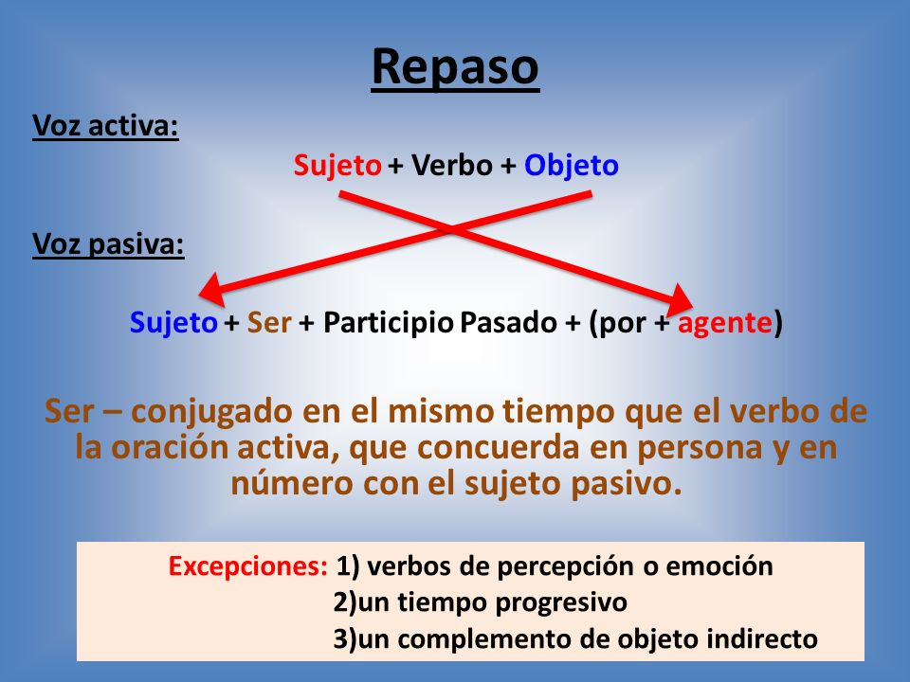](https://www.google.es/url?sa=i&url=https%3A%2F%2Fslideplayer.es%2Fslide%2F1045007%2F&psig=AOvVaw32kjlhfzjvVyzOXAKPENKC&ust=1589890173432000&source=images&cd=vfe&ved=0CAIQjRxqFwoTCKi5gcuwvekCFQAAAAAdAAAAABAN)

[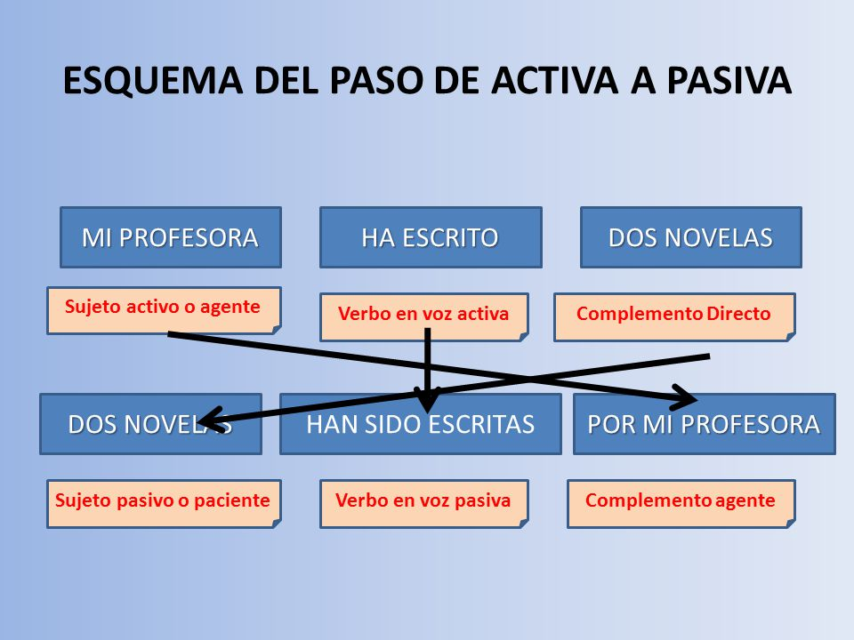](https://www.google.es/url?sa=i&url=https%3A%2F%2Fgomezcejasprofedelengua.jimdofree.com%2Fies-colonial%2F1%25C2%25BA-bachillerato-ies-colonial%2Fsegunda-evaluaci%25C3%25B3n%2F&psig=AOvVaw32kjlhfzjvVyzOXAKPENKC&ust=1589890173432000&source=images&cd=vfe&ved=0CAIQjRxqFwoTCKi5gcuwvekCFQAAAAAdAAAAABAS)

[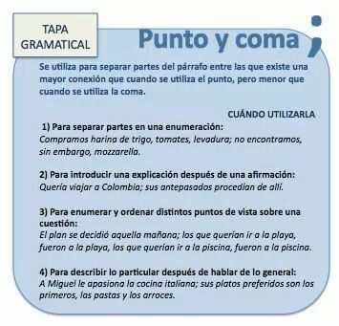](https://www.google.es/url?sa=i&url=https://www.pinterest.at/pin/431219733044465480/&psig=AOvVaw1kQWFgYmMlsJRJe-pok8z_&ust=1589276926857000&source=images&cd=vfe&ved=0CAIQjRxqFwoTCNjIxYzEq-kCFQAAAAAdAAAAABBe)

[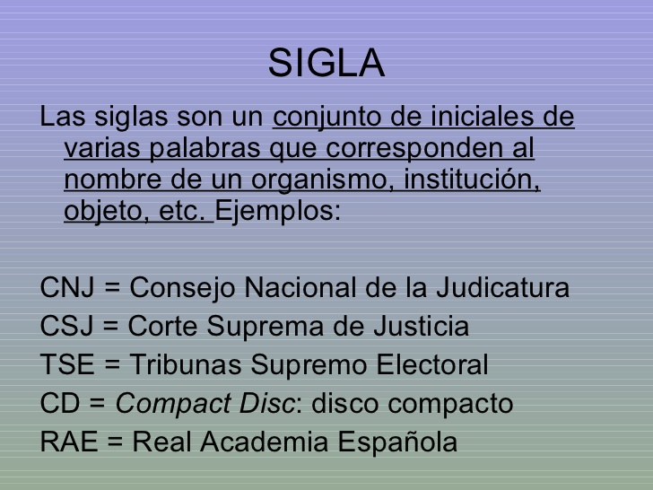](https://www.google.es/url?sa=i&url=https%3A%2F%2Fes.slideshare.net%2Fedurnemm%2F2-las-siglas-y-los-acrnimos-presentation&psig=AOvVaw2bFcXRrt-WlD2zTvY4Rf3m&ust=1589899959076000&source=images&cd=vfe&ved=0CAIQjRxqFwoTCNjgrI3VvekCFQAAAAAdAAAAABAP)

[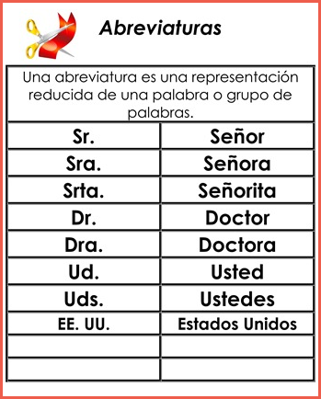](https://www.google.es/url?sa=i&url=https%3A%2F%2Fwww.poemas-del-alma.com%2Fblog%2Ftaller%2Fconsejos-escribir-abreviaturas&psig=AOvVaw1C2EGu7c7rZe5Evp13wlVB&ust=1589900098247000&source=images&cd=vfe&ved=0CAIQjRxqFwoTCNC-ncnVvekCFQAAAAAdAAAAABAO)