I mportant Verbs II
Worksheet 4

Name: _ Date:

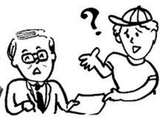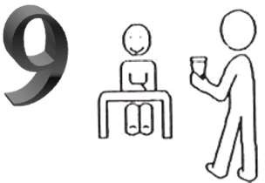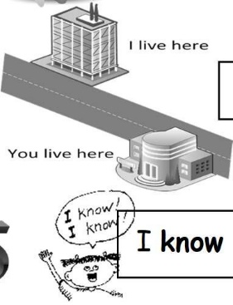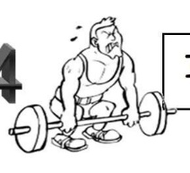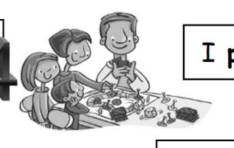I want a dog for Christmas.
I ask the teacher if I have a doubt.

I answer when the teacher asks
me.
lay in the park every afternoon.

I need to look for my keys. I always find my keys.
I p

I always keep the worksheets in my folder.

Remember to do your homework!!
I bring you a glass of water.

I think a lot when I do my homework. always understand the exercises.
I

I buy sweets every weekend.
I live in Lanzarote.

try to do my homework every day. how to do the exercise.
I know
I

I always win when I play chess. I eat vegetables every week.
I like Science. It’s cool!!
You have to go to school.

1º What do you want to do in the English classroom? Write.

I want to .

- .

2º What don’t you want to do in the English classroom? Write.

- I don’t want to_ .
- _______________________________________________________________.

3º Use the following words: go, say, bring, eat and play. T

h ave to use!!

I have to a pen and a pencil to school.
  - You can _ any food if you are hungry.
  - They always to the park at the weekend.
There is one word that you don’t

  - I ‘good morning’ when I see my teacher in the morning.

4º Write a sentence with the following words: play, live, eat and buy.

