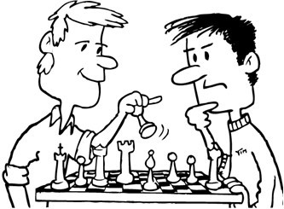
H obbies
f) They play chess
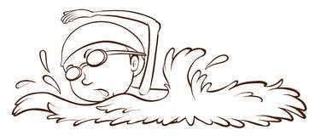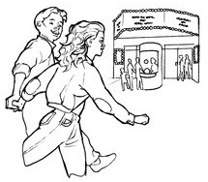Name:
b) I swim
c) We go to the cinema
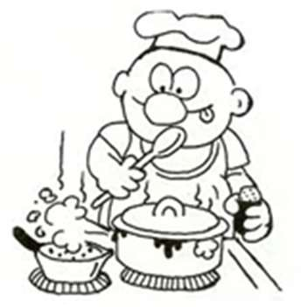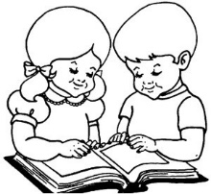
a) I cook at home
e) They read a book
d) They watch TV

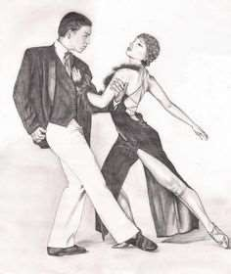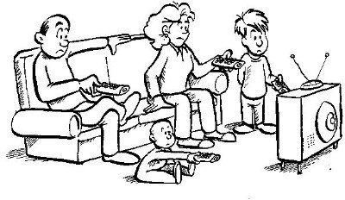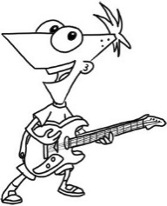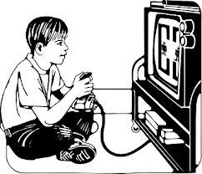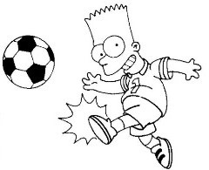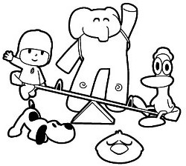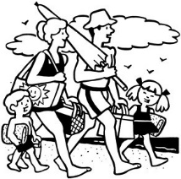1º Look at the hobbies. Write two things you like to do and two things you don’t like to do. Example: I like to sing. I don’t like to play basketball.
g) I play the guitar
h) We dance
j) I play videogames
k) I play football
l) I play with my
friends
i) They go to the beach
- .
____
- .
____
- .
____
____.

2º Write something you do every day, every week, every weekend, every month and every year. Example: I go to school every day.

.
- .
- .
- .
- .

3º Read and answer.
- Write the three months of the spring: _

- How many days are there in a week?

- Write down the two days of the weekend. _
- Write down the four seasons.

4º Match the sentences:
- You win the trophy!!
- I often buy you are a nice person.
- I have to food in the supermarket.
- I think that do my homework.

