# D aily Routines and Time

Worksheet 15

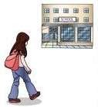Name: Date:

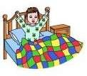

a) I wake up



c) I brush my teeth

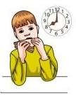

b) I have breakfast

d) I go to school



e) I have lunch



f) I study and I do my homework at home



g) I clean the house



h) I walk the dog

## 1º Write two things you do in the morning, two in the afternoon and two in the evening.



i) I have dinner



j) I watch TV

k) I have a shower

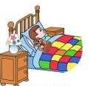

l) I go to sleep

Example: I wake up and I brush my teeth in the morning.



.



.



.