Adverbs of Frequency
Worsheet 8

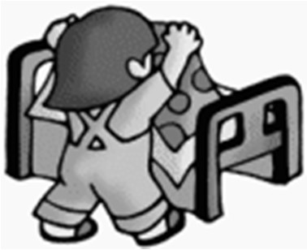
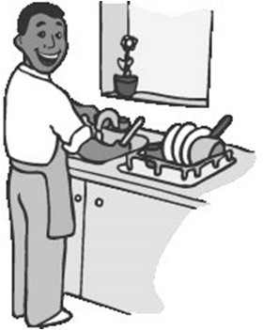
Name: Date:

I always make my bed
I often do the dishes
I cook at home sometimes I sometimes cook at home

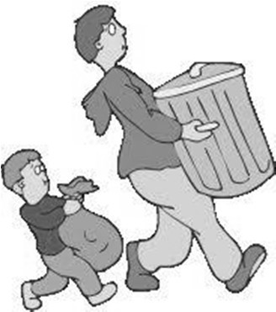
1º Read and answer.
I never take the rubbish out
Always = every day = 100% Often = many days = 75% Sometimes = some days = 50% Never = 0%
- How often do you make your bed? .
- How often do you do the dishes? .
- How often do you cook at home? _.
- How often do you take the rubbish out? .

2

º Copy the true sentences.
a) _.
- .
- .
- .

- She is tall | – She is fat | – She is pretty | – She is ugly
- She is short | - She is thin | – She has small eyes | – She has long legs

3º Read and colour.
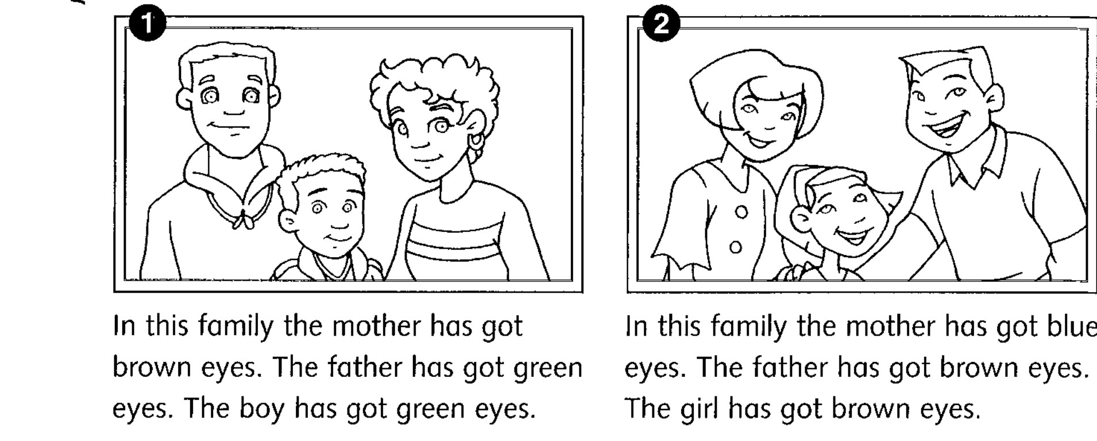
4º Write a sentence with the following words: give, play, live and read.
- .
- .
- .
- .

