V erbs in Past 1
Worksheet 25

Name: Date:
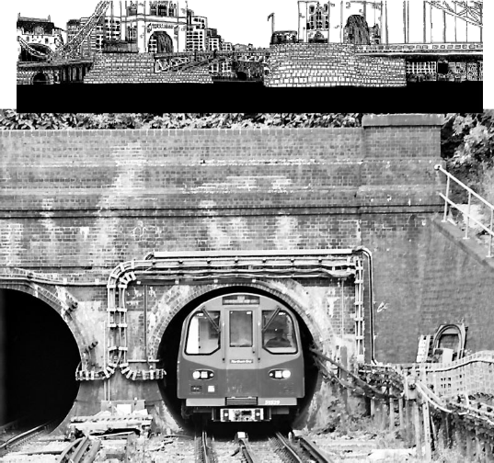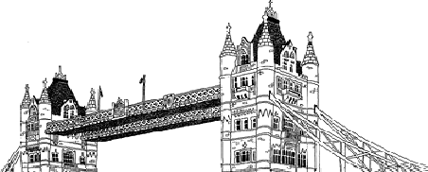1º Read the text and underline the verbs you can find. Then, answer the questions. Last summer, I went on holiday to London with my parents. London is in England. I saw the London Tower Bridge and I loved it. We took the tube to get there. We went to a restaurant and we ate fish and chips but the food was disgusting!!! We stayed for two days and we liked the city. We want to go back next summer.
- When did he go to London?

- Who did he go with?

- Where is London?

- How long did they stay in London?

- How did they get to London Bridge?

- What did they do in London?

2º Write a similar sentence using the past
- I go to Haría every Sunday. – I went to Haría last Sunday
- I go to Teguise every Monday. -
- I see a cat in my neighbourhood every week. -
- I stay at my granny’s house every Sunday. -
- I eat paella every weekend. -
- I take the car when I go to Playa Blanca. -

3º Write a text about where you went last summer. You can make it up. Use the following verbs (go, eat, stay, see, hate)
______________________________________________________________________________________________________________________________________________________________________________________________________________________________________________________________________________________________________________________________________________________________________________________________________________________________

