What do you want to do today?

Worksheet 5

Name: Date:

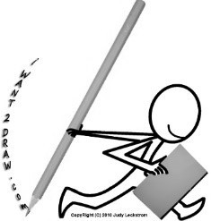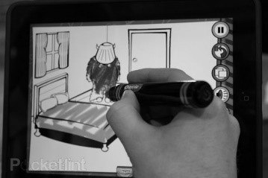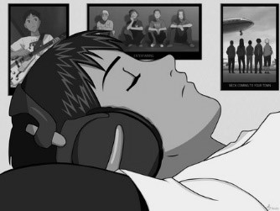

# I want to draw a picture

*I want to colour a picture*

*I want to listen to music*

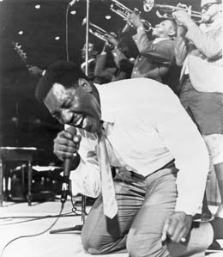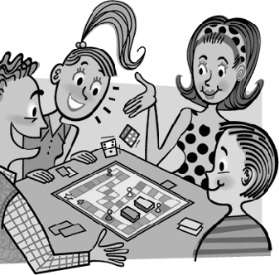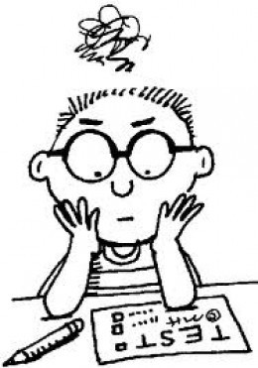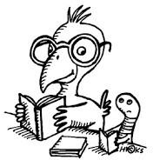

# I want to sing a song I want to play a game I don’t want to do an exam I want to read

## Can I have…? (polite) – I want…!!! (rude)

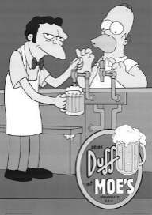

Can I have a beer?

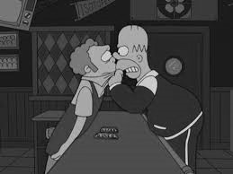

I WANT A BEER!!!

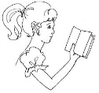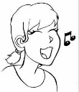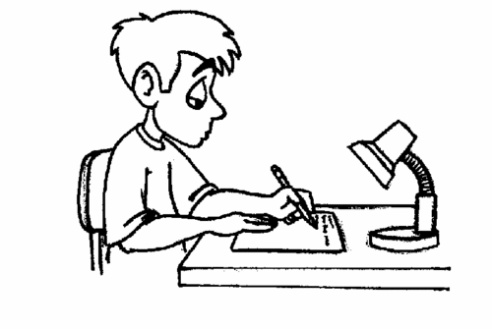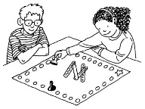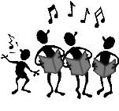

**1º What does he/she want to do?**

1. She want_______________________________________

c)

**2º What do they want to do?**

a) They want

b)

c)

.

.

.

.

**3º Write a sentence with the following words:** want, go, give and read.



## 4º Look at the monsters. Match each sentence to the correct picture.

* 1. 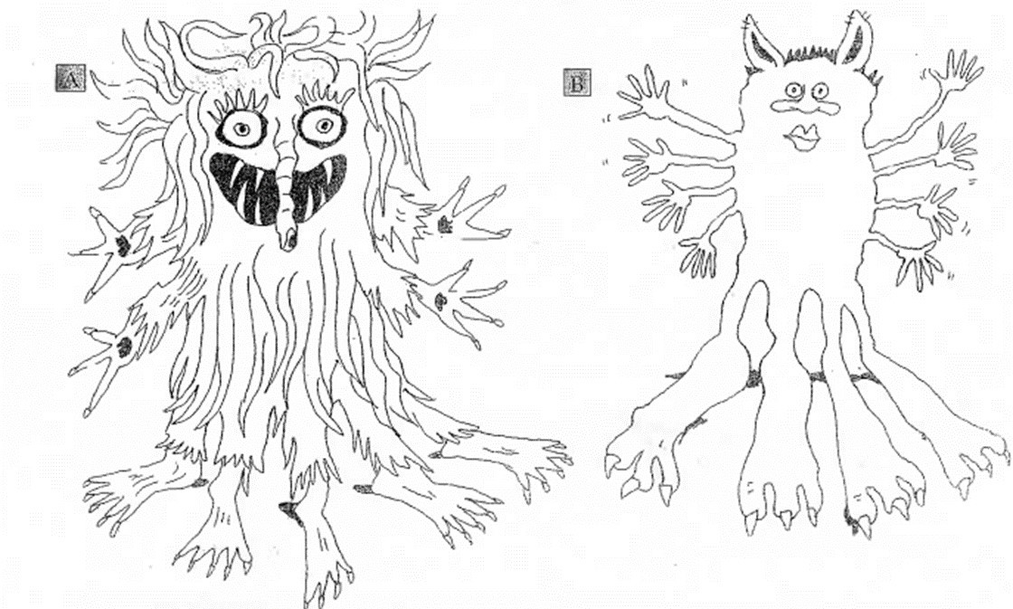He has a big nose.
  2. He has a small mouth.
  3. He has four big feet. _
  4. He has four short arms.
  5. He has short hair.
  6. He has a long nose.
  7. He has five thin legs. _
  8. He has big ears.
  9. He has eight small hands.
  10. He has long hair.