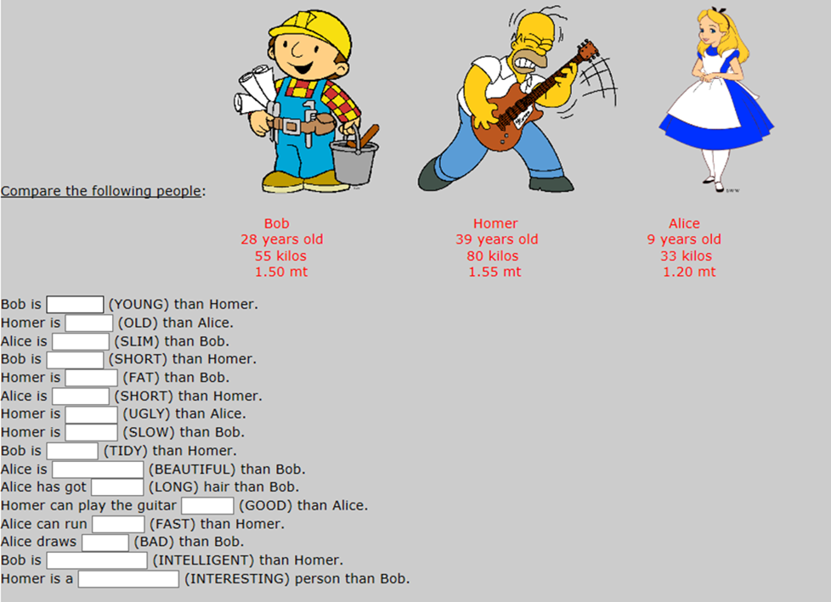
2. NOW WRITE 5 SENTENCES USING THE SUPERLATIVES:
EJ: Alice is the slimest.

