V erbs in Past 2
Worksheet 25

Name: Date:
1º Read the text and answer the questions. Give a l ong answer.
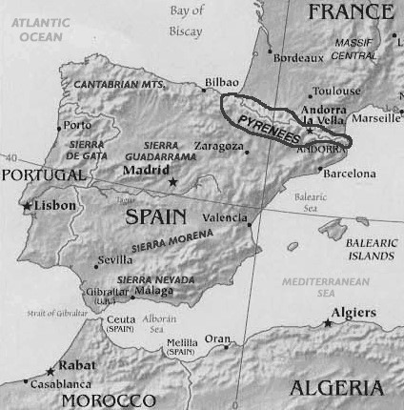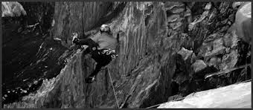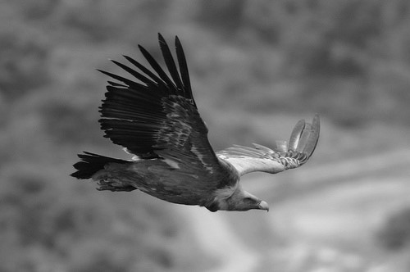Three years ago, I went for three days to the Aragonese Pyrenees with my two best friends. The Pyrenees is a group of mountains situated between France and Spain. On the first day, we went climbing and we saw many eagles. On the second day,
it was raining all day long and we didn’t go hiking. However, we stayed at the hotel and we watched a nice film. On the third day, we went hiking but we didn’t see any eagles. The Aragonese Pyrenees is a good place to go on holidays!!
- Where are the Pyrenees?

- When did he go to the Pyrenees?

- Who did he go with?

- How long did they stay in the Pyrenees?

- Did they go hiking on the second day?

- What did they do on the third day?

2º Imagine that you went to the Pyrenees two weeks ago. Write three things you did and three things you didn’t do. Use the verbs (go hiking, go climbing, take, see, like,
eat). Example: 1º I went hiking 2º I didn’t go climbing
- d)
- e)
- f)

3º Answer the questions. You can make up the answers.
1º When was the last time you rode your bike? 2º When was the last time you read a book? 3º When was the last time you went to the beach? 4º When was the last time you ate meat? 5º When was the last time you took a plane? 6º When was the last time you went to the cinema? _

