Bugs World 5
Unit 2 RECYCLED GRAMMAR
Name: Class:

Can / can’t
I
He  She | can  can’t | swim.
They

Can | you he she they | swim?

Yes, | I  he she they | can.
No, |  | can’t.

1 Answer the questions.
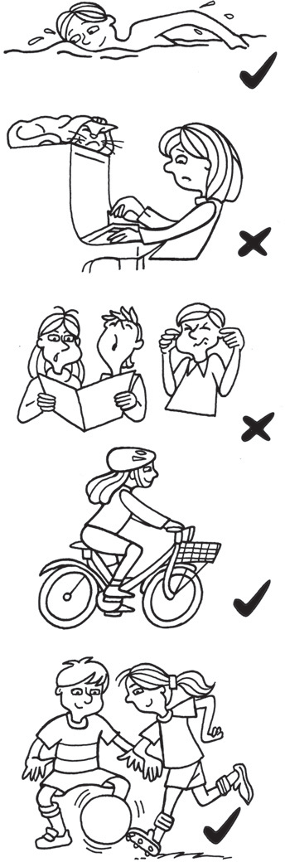
- Can he swim? Yes, he can.

- Can she play the piano? No, .

- Can they sing? .

- Can she ride a bike? .

- Can they play football? .

2 Order and write the sentences.
- bike / She / ride / can / a She can ride a bike.
- English / speak / can’t / He .
- speak / They / Spanish / can .
- volleyball / can’t / She / play .

3 Write sentences about what you can and can’t do.
1 I can play basketball. ₂ I can’t swim.
3 . 4 .
5 . 6 .

