# V ocabulary for descriptions

ENGLISH

Name: Date: _

# T he face

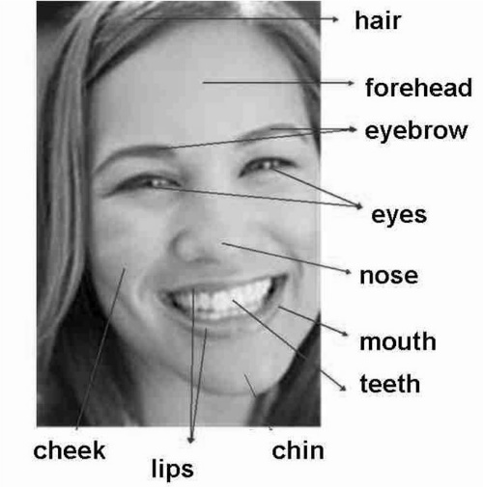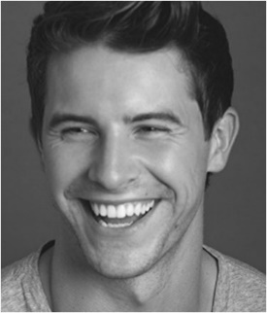

He is handsome. His smile is lovely

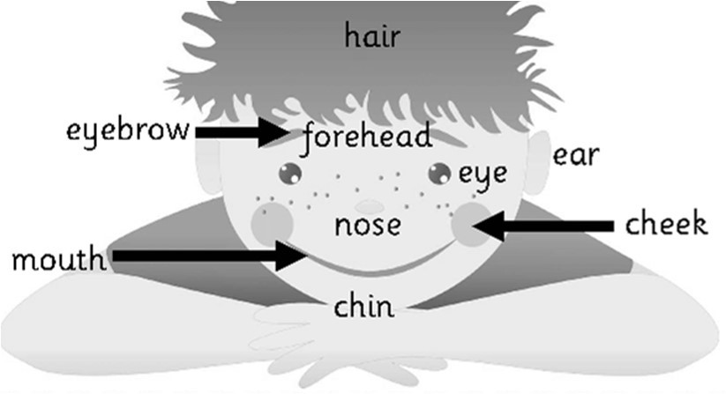

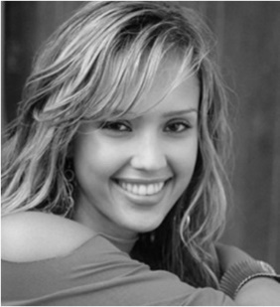

She is pretty. She has a nice smile

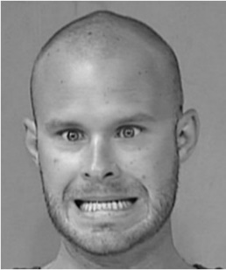

He is ugly. His smile is terrible

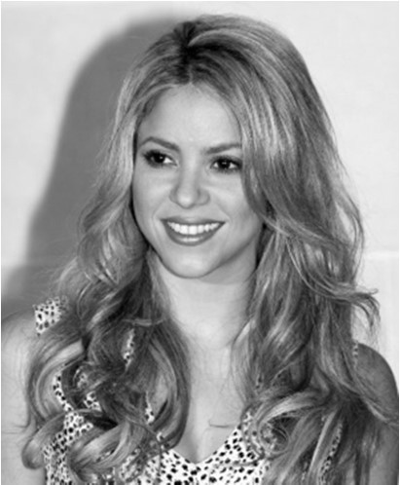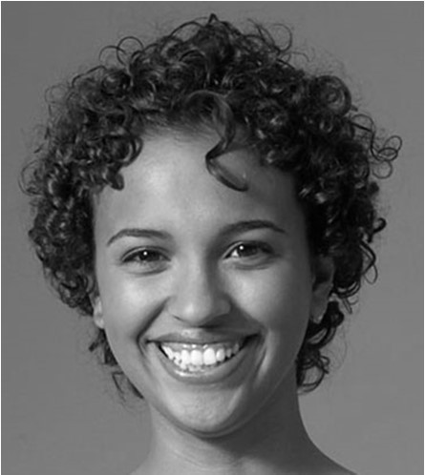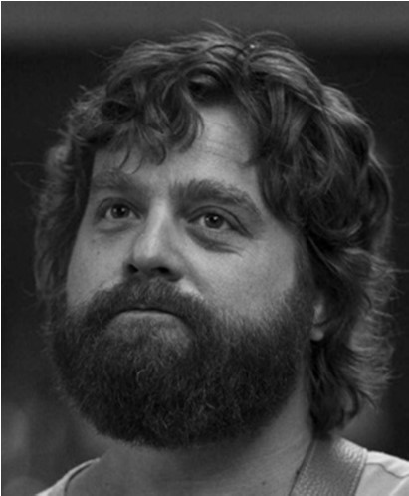**H air**

____________________

_______________________

__________________

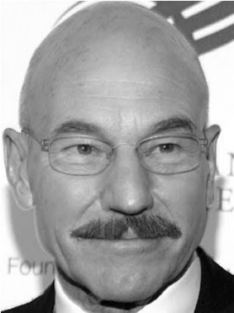

He is bald and he

has a moustache. He wears glasses

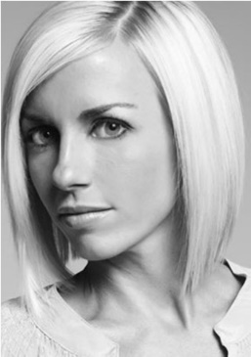

Short straight blonde hair

## 1º Draw and colour the eyes.

______________

Long wavy brown hair

Short curly black hair

He has a beard

Big green eyes

Small blue eyes

Big brown eyes

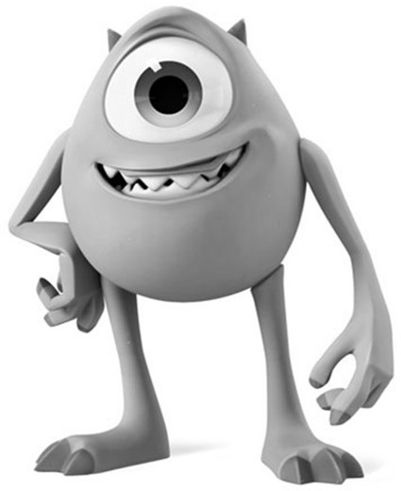**2º Colour the description**

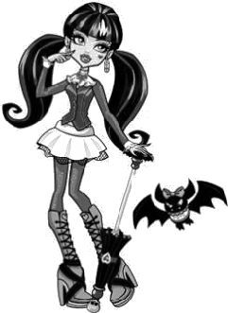

- She is slim.

-

-

-

.

.

.

- He has big teeth.

-

-

-

.

.

.

1. Victoria is wearing a blue tracksuit.
2. Victoria’s mother is wearing a red dress and black shoes.
3. Victoria’s father is wearing brown trousers and a green shirt.
4. Victoria’s grandfather is wearing a yellow jumper and blue trousers.
5. Victoria’s grandmother is wearing a purple skirt and a grey blouse.
6. Victoria’s sister is wearing a blue skirt and a yellow T-shirt.
7. Victoria’s brother is wearing an orange T-shirt and pink shorts.

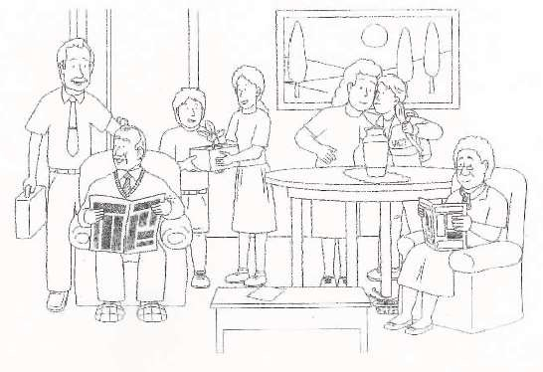

Victoria

## 2º Describe the characters.