There was – There were
ENGLISH
Name: Date:

1º Have a look at the pictures. What things were there in the living room before the burglary? What things are there after the burglary?
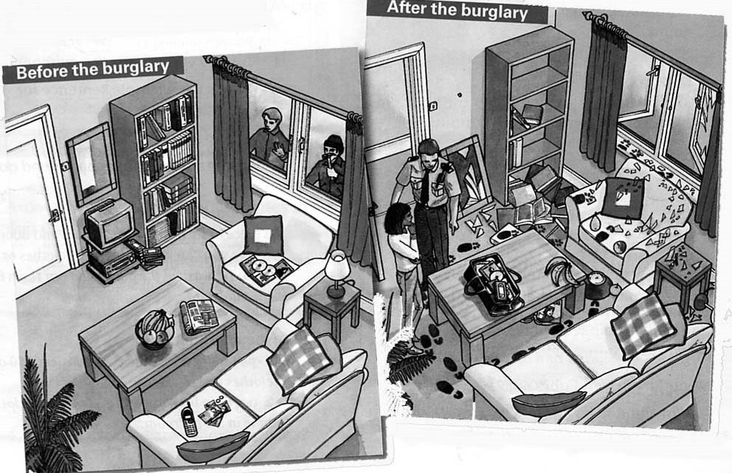
Before the burglary
- There was a phone on the sofa.
- There were three cushions on the sofas.
- There
-
-
-
-
-

After the burglary
- There is a phone on the sofa
- There are footsteps on the floor.
- There
-
-
-
-

