**C omparatives and superlatives.**

**ENGLISH**

Name: Date:

1º Compare the kids and write the sentences.

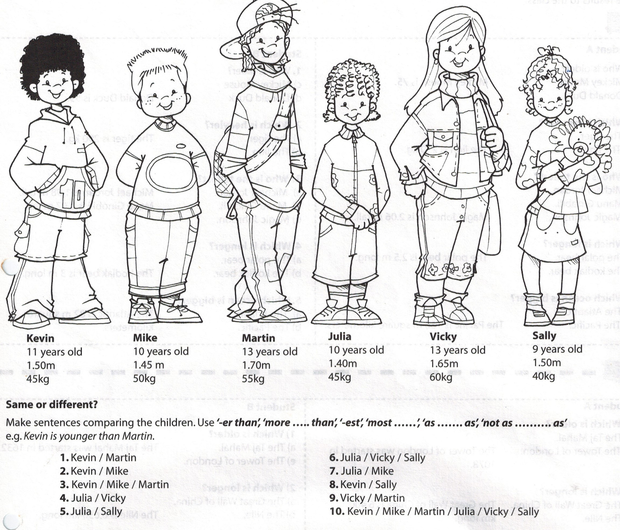



2º Now write superlatives sentences.



-

-