**S axon Genitive, Ordinals, there is / are**

ENGLISH

Name: Date:







It’s Bart’s skateboard

It’s Lisa’s saxo

# 1º Read and answer the questions.

1. Whose car is that? _
2. Whose book is it?

**2º Match the questions and the answers.**

Do you like playing basketball? In Tenerife

Where do you live? I’m eight

How old are you? Rice

What’s your favorite food? One sister

What’s your name? Yes, I do

Do you have any brothers or sisters? My name is Carmen

**3º Look at the line of animals. Complete using:** first, second, third, fourth and last.



1. The elephant is . d) The cat is .
2. The lion is . e) The pig is .
3. The dog is .

**4º Look at the picture and answer the questions. Use “there is” or “there are”**

1. How many T-shirts are there?
2. How many balls are there?
3. How many drawers are there?
4. How many Teddy’s are there?
5. 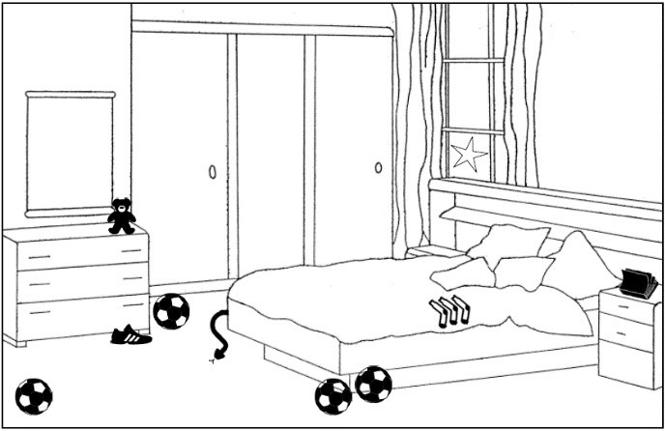How many beds are there?