# Animals

ENGLISH

Name: Date:

## 1º Follow the steps to colour the continents.

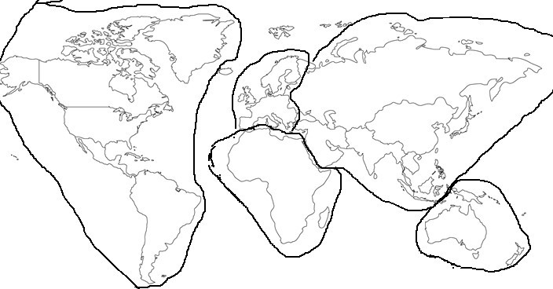

1st Colour Europe with a blue pencil.

2nd Colour America with an orange pencil. 3rd Colour Africa using a green pencil.

4th Colour Oceania using a red pencil. 5th Colour Asia using a yellow pencil.

## H erbivores, Carnivores and Omnivores

A herbivore is an animal that eats plants, herbs, fruit, roots, etc. Examples of herbivores are horses, cows, rabbits, bees and sheep.

A carnivore is an animal that eats meat. Examples of carnivores are lions, tigers, eagles, spiders (spiders eat other insects) and sharks.

An omnivore is an animal that eats plants and meat. Examples of omnivores are human beings, monkeys and bears.

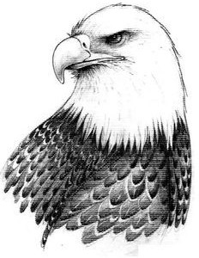 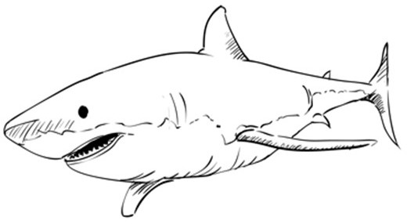 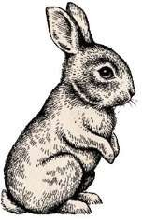

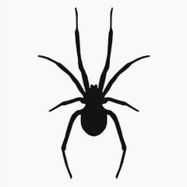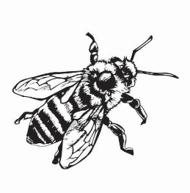

## 2º Write three examples of carnivores, omnivores and herbivores.

1. Carnivores
2. Herbivores
3. Omnivores

## E ndangered and threatened animals

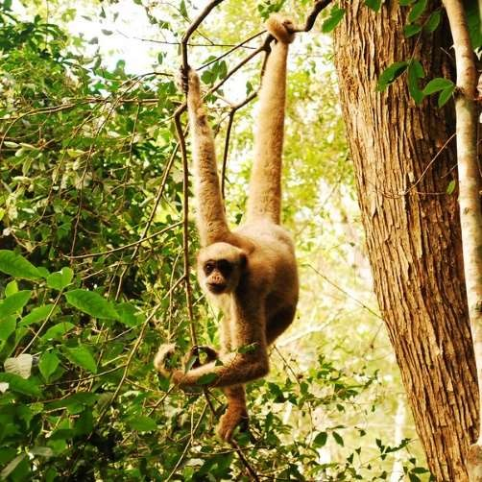Animals can be common or endangered (endangered and threatened are synonyms). Common animals are not going to become extinct, whereas endangered animals are in danger of becoming extinct.

Some of the most threatened or endangered species are:

1. The Javan Rhino. There are less than 100 alive.
2. The Spider monkey. There are around 1000 alive.

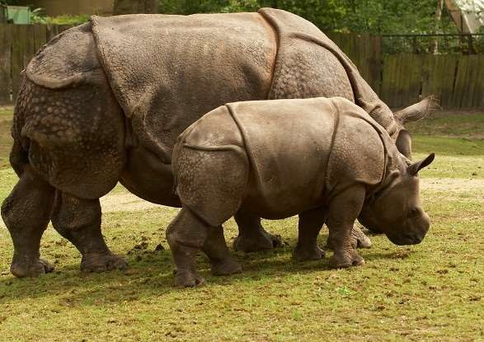

## 3º Read the information and answer the questions.

* 1. 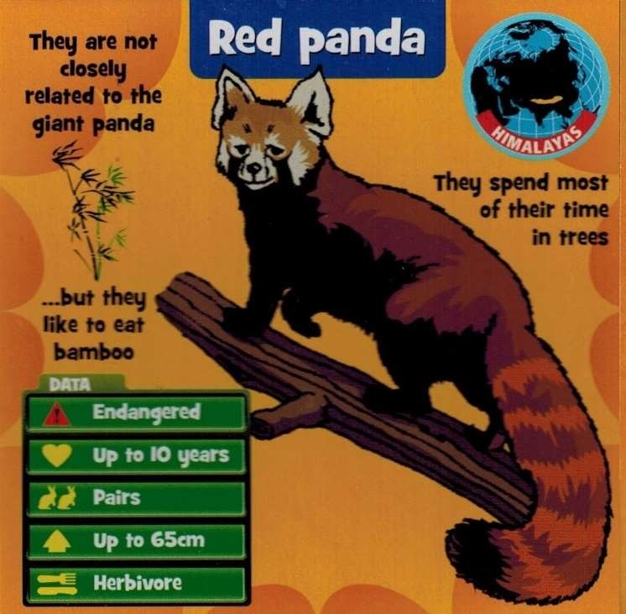Where are red pandas native to?
  2. Is the red panda standing on all four legs?
  3. Do these animals like eating bamboo?
  4. Are these animals solitary?
  5. Where do red pandas spent most of their time?
  6. Does the red panda have a striped tail?