Senses II – Exercises - Science

**ENGLISH**

Name: Date: _

# Exercise 1. Match each sense with its correspondent organ.

1. Sight ears
2. Hearing nose
3. Smell tongue
4. Taste eyes
5. Touch skin

**Exercise 2. Write the parts of the eye:** eyelashes, eyebrow, eyelid, iris and pupil.

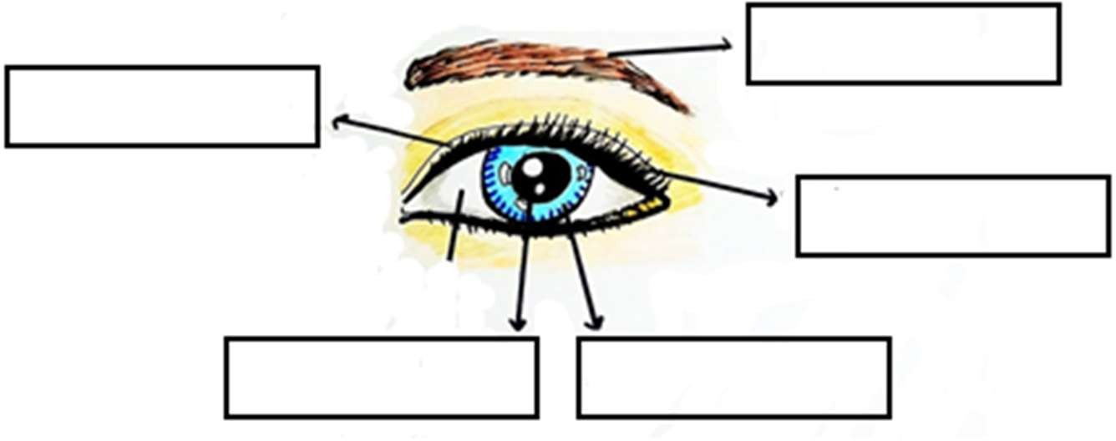

# Exercise 3. Write three things we can do to look after our eyes.

- .

- .

-

# Exercise 4. Write one thing we can do to look after our ears.

- .

# Exercise 5. Write one thing we can do to look after our skin.

-