L ist of Important Verbs
ENGLISH
Name: Date:

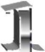
- I write everyday at school.
- I wrote a story yesterday.
- I read a book when I go to bed.
- I read “Three Little Pigs” last year.
- I give the exam to the teacher when I’m finished.
- I gave a present to my mum last month for her birthday.

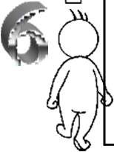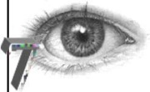
- I have the world in my hands.
- I had fun in the school trip last year.
- I find minerals in the playground every year.
- He found 10 euros in the park yesterday.
- I go to school during the week.
- I went to visit my granny last weekend.
- I see my friends when I go to the park.
- I saw you in the park two days ago.

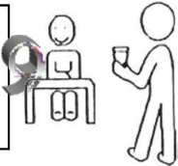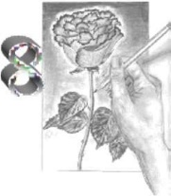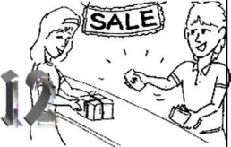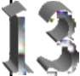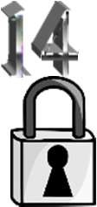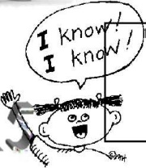
- I draw when we have Arts.
- I drew a flower on Mother’s Day.
- I bring you a glass of water.
- I brought a cake to school last year to celebrate my birthday.
- I think a lot when I do my homework.
- I thought it was a good idea.
- I always understand the exercises.
- I understood the teacher explanation.
- I buy sweets every weekend
- I bought a present for my mum.
- I say hello to dad when I come home.
- I said a bad thing to my classmate.
- I always keep the worksheets in my folder.
- I kept all my toys in a box when I was seven.
- I know how to do the exercise.
- I knew that my exam was perfect.

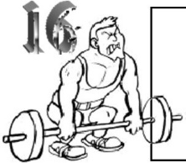
- I try to do my homework every day.
- I tried to do the exercise at home but it was impossible.
- Take my heart, please!!
- I took a red pencil from your pencil case.

- I always win when I play chess.
- We won the school football championship two years ago.
- I eat vegetables every week.
- I ate paella last Sunday.

L ist of Important Verbs (-ED)

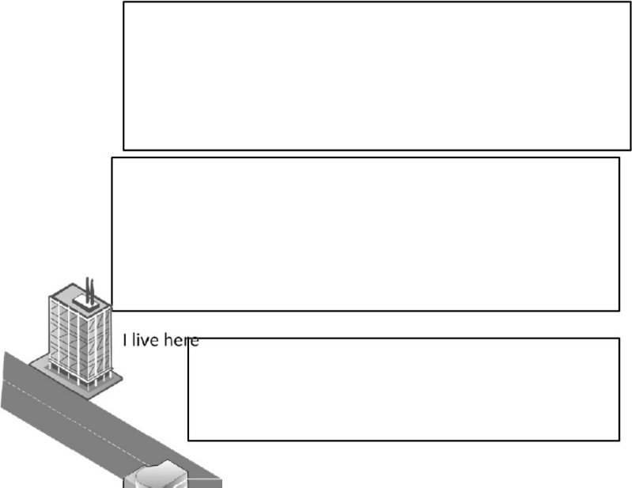
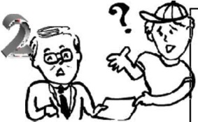
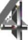
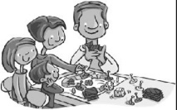
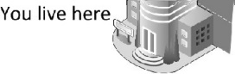
- I want a dog for Christmas.
- I wanted to be an astronaut when I was six.
- I like Science. It’s cool!!
- I liked Real Madrid last year but I like Atlético de Madrid this year.
- I play in the park every afternoon.
- I played a board game with my family three days ago.
- I ask the teacher if a have a doubt.
- I asked my brother to help me with my homework.
- Remember to do your homework!!
- I remembered yesterday that I had to go to the dentist.

- I live in Arrecife.
- I lived in Tenerife last year.

- I answer when the teacher asks me.
- I answered all the questions in the quiz we did yesterday.

1º Write 5 sentences using the following verbs in past: see, buy, eat, give and sleep. You have to say when it happened (yesterday, last month, two days ago…)
- .
- .
- .
- .
- .
2º Write three things you didn’t do last weekend.
-
-
-

